**REACT**

**1. Creating a new React Application with the name “myfirstreact”, Run the application to print “welcome to the first session of React” as heading of that page.  
  
Step 1 :**

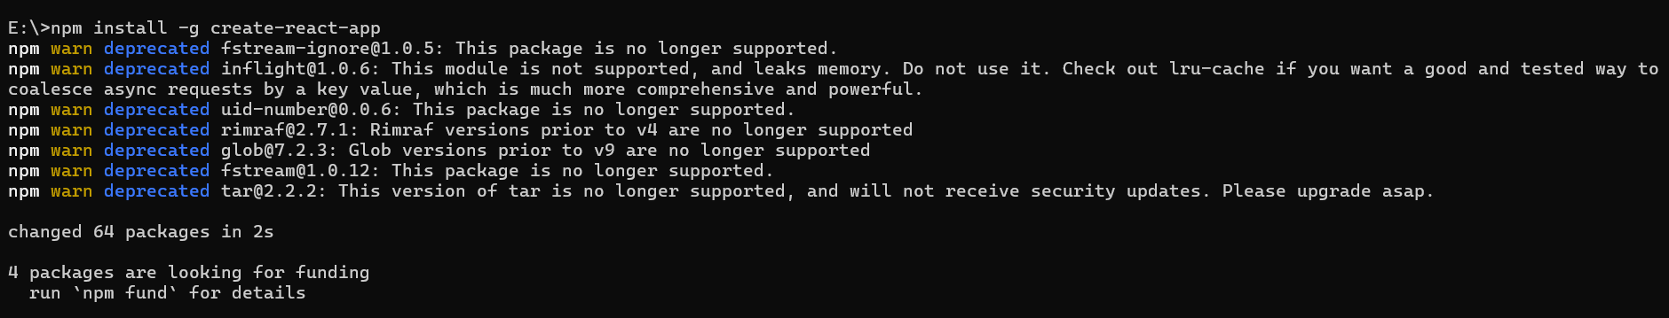

**Step 2 :  
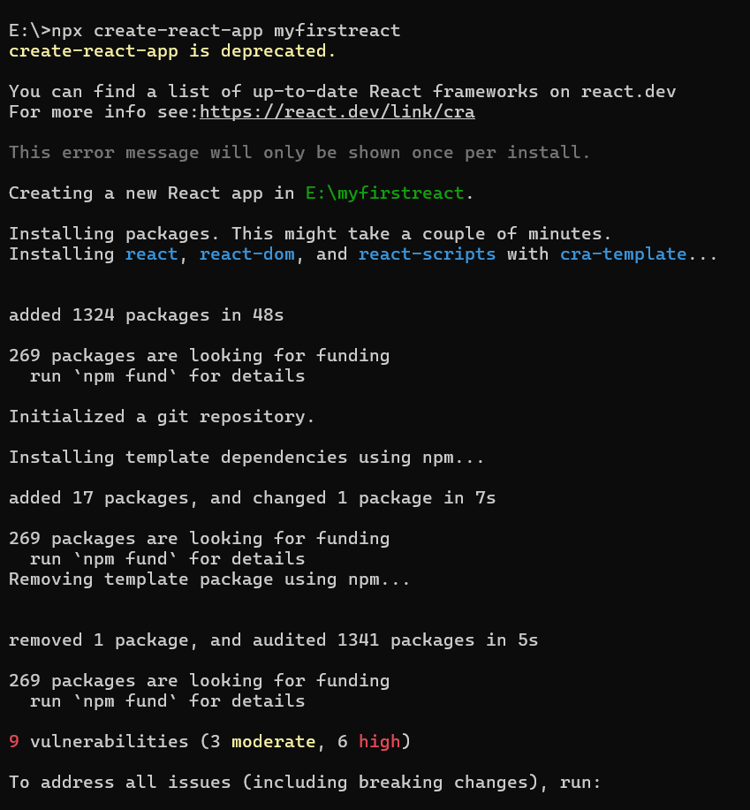**

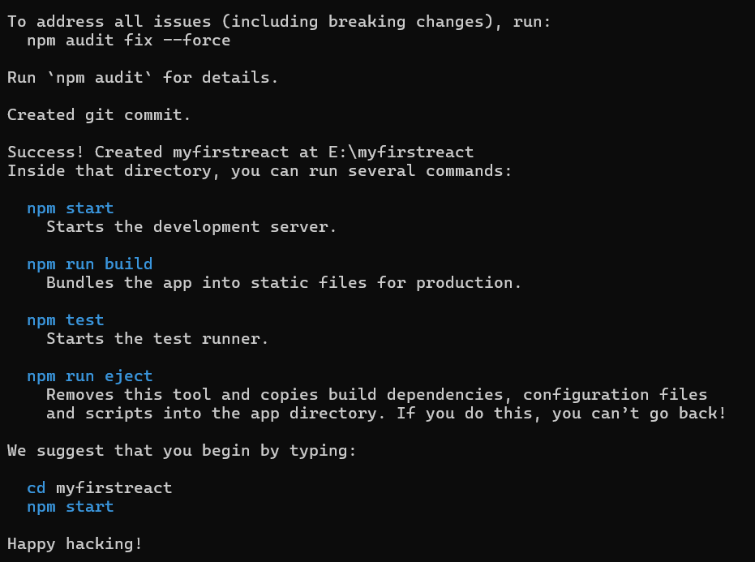

**Step 3:  
**

**Step 4 :**

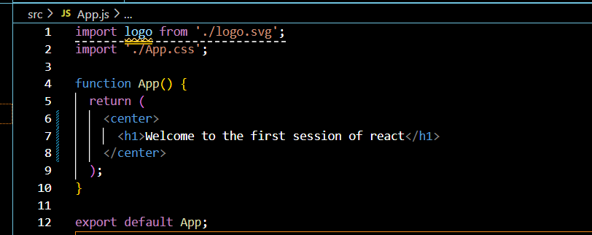

**Step 5 :**

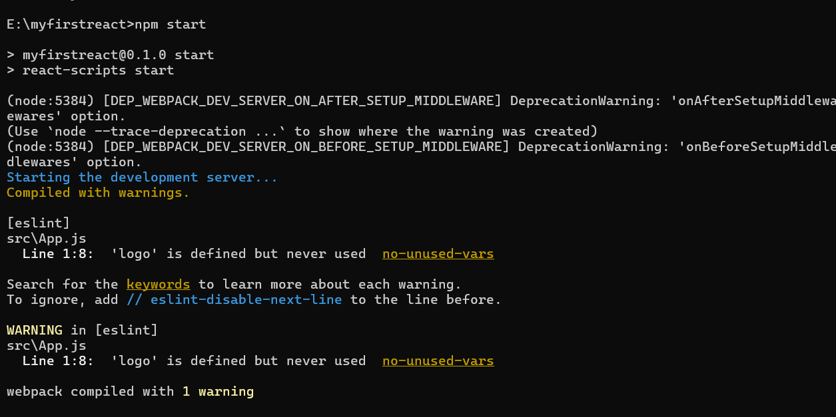

**Output:  
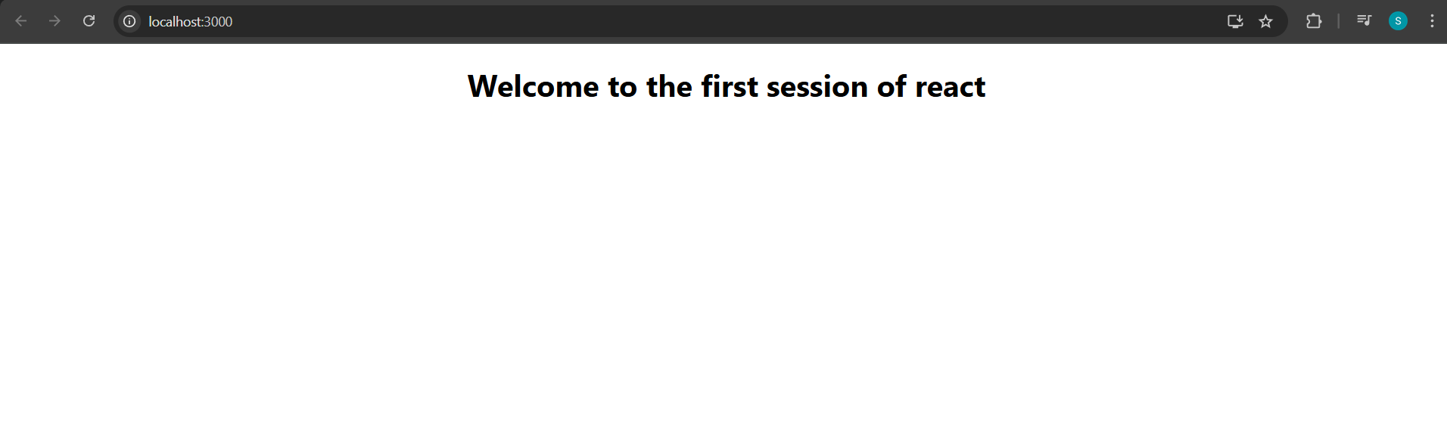2.** **Creating a react app for Student Management Portal:**

**Components:  
Home.js:  
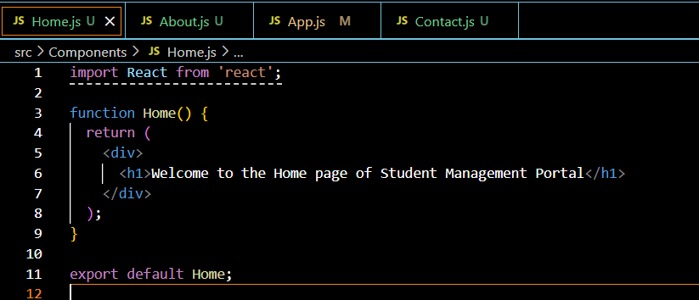**

**About.js:  
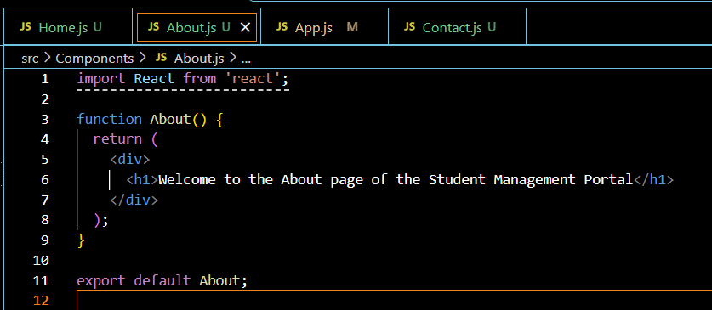**

**Contact.js:  
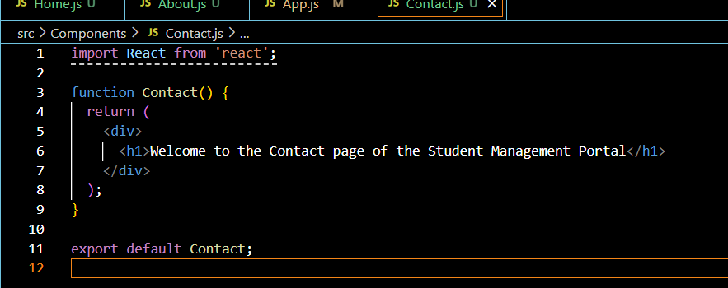**

**App.js:  
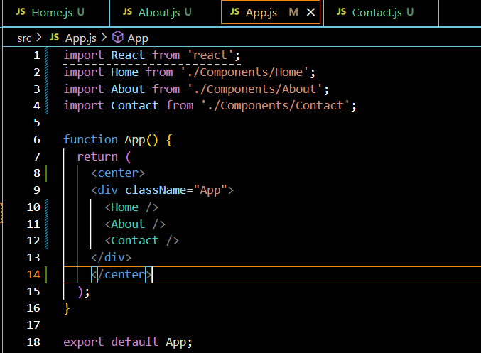**

**Output :  
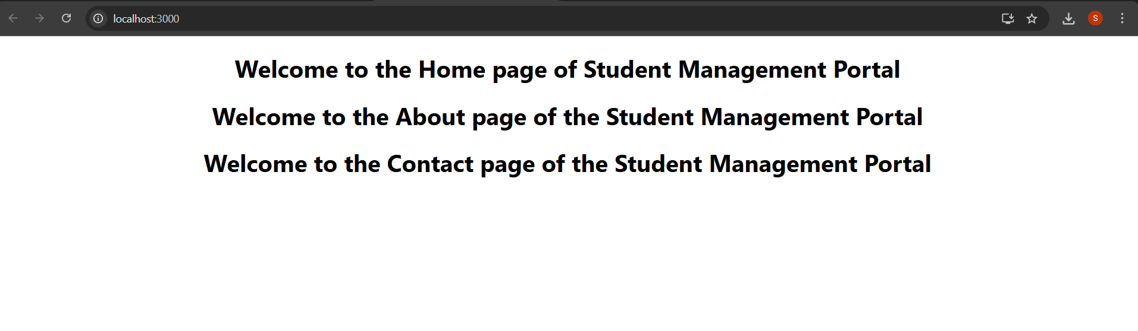**

**3.** **Creating a react app for Student Management Portal named scorecalculatorapp and create a function component named “CalculateScore” which will accept Name, School, Total and goal in order to calculate the average score of a student and display the same:  
  
Components:  
CalculateScore.js:  
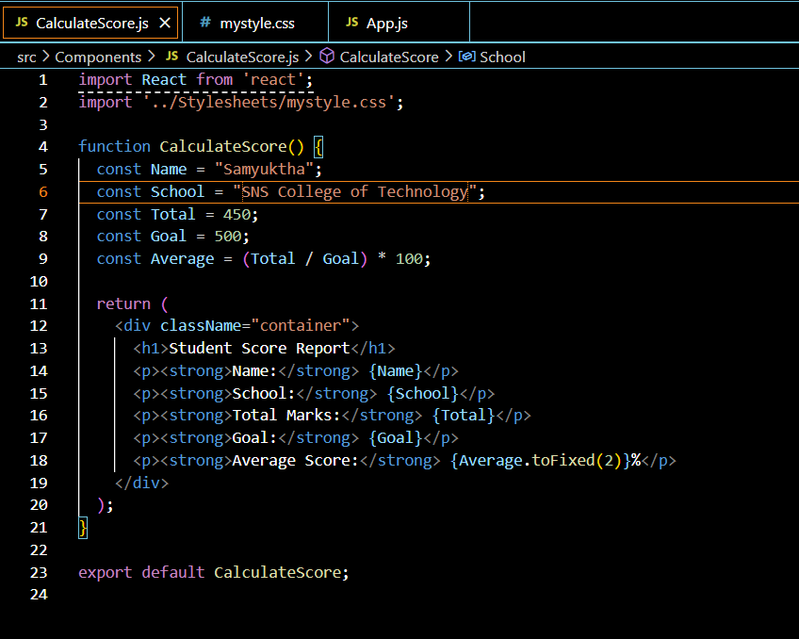**

**mystyles.css:  
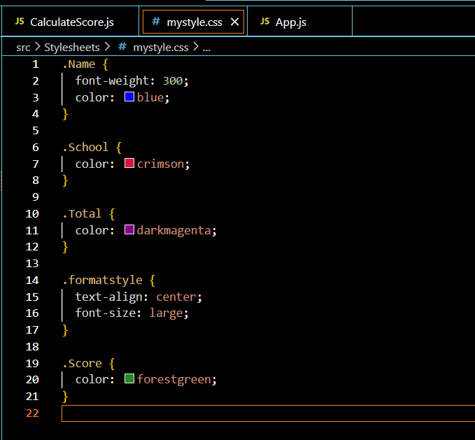**

**App.js:  
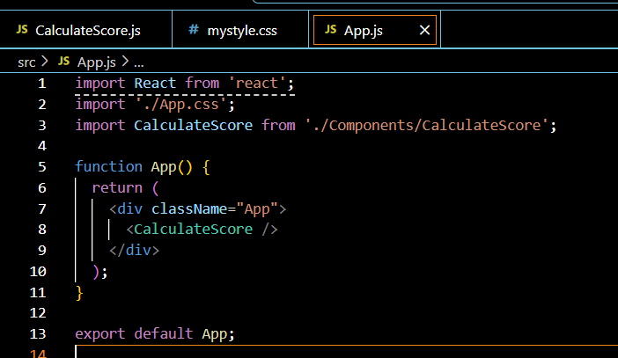**

**Output:  
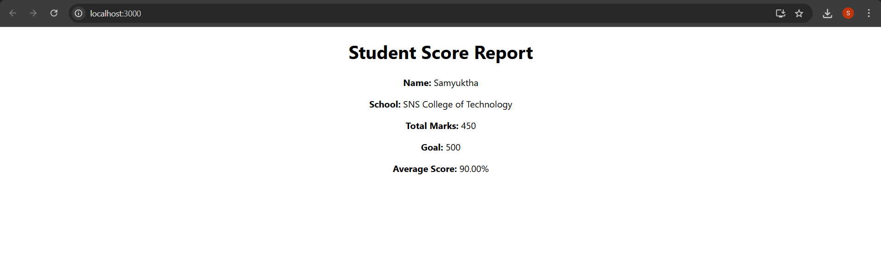**

**4. Creating a new react application using *create-react-app* tool with the name as “blogapp”:  
post.js:  
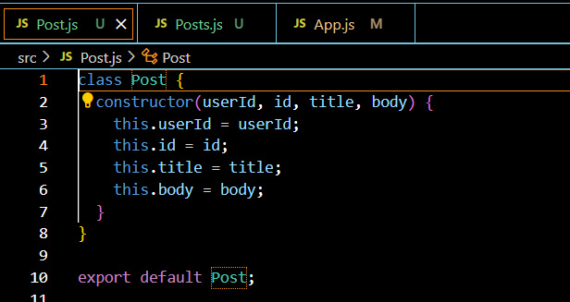**

**Posts.js:  
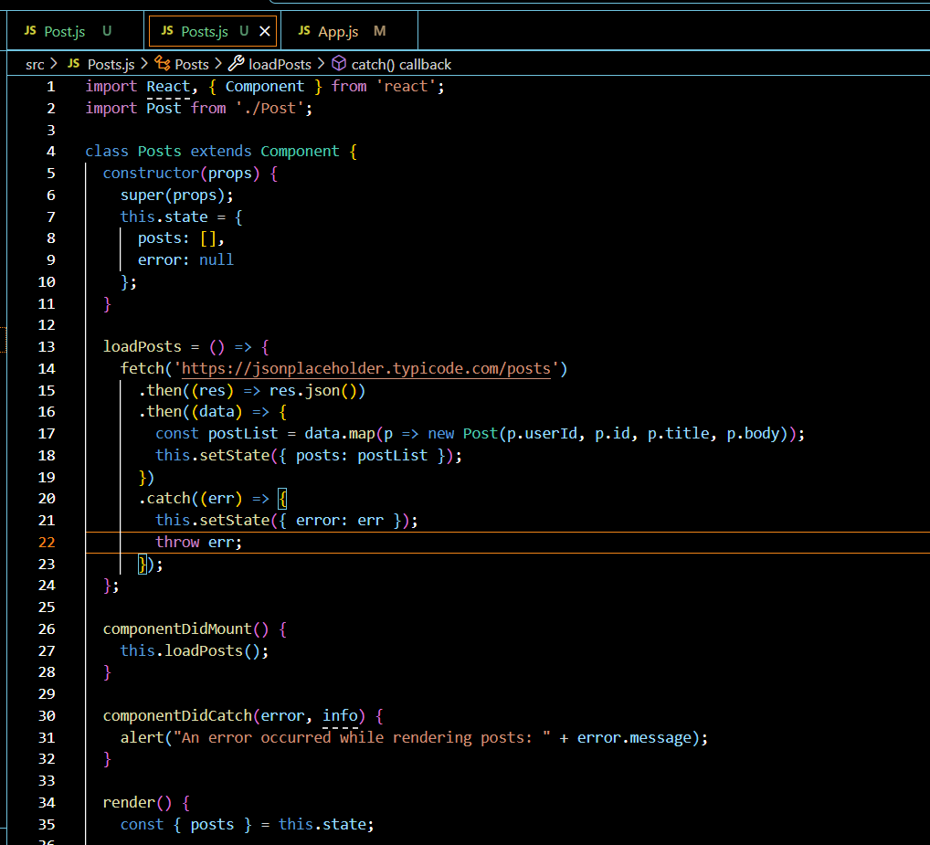**

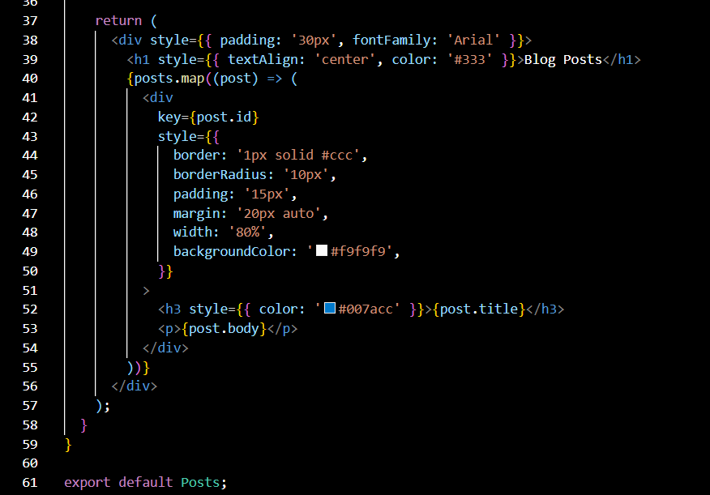

**Output:**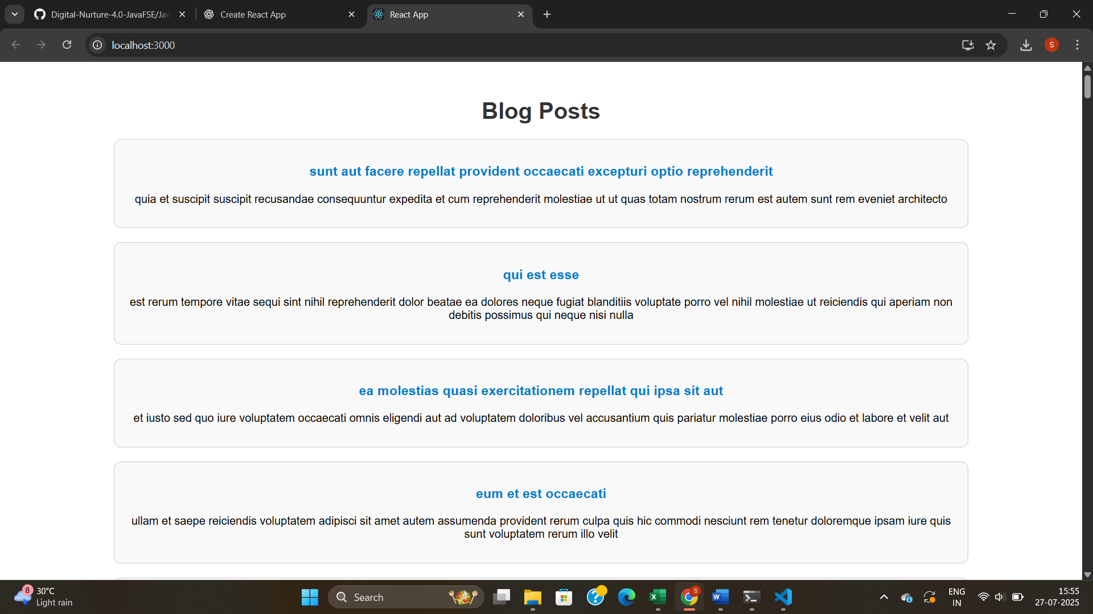

**5. Create a dashboard containing the details of ongoing and completed cohorts.**

**CohortDetails.module.css:**

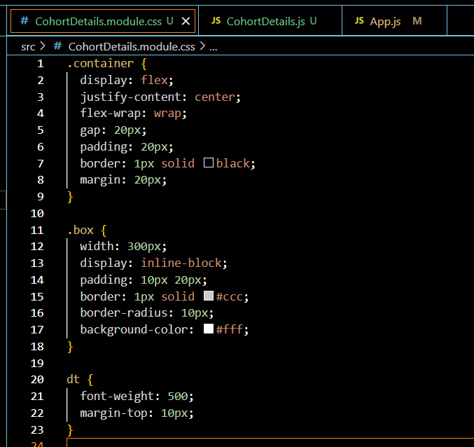

**CohortDetails.js:  
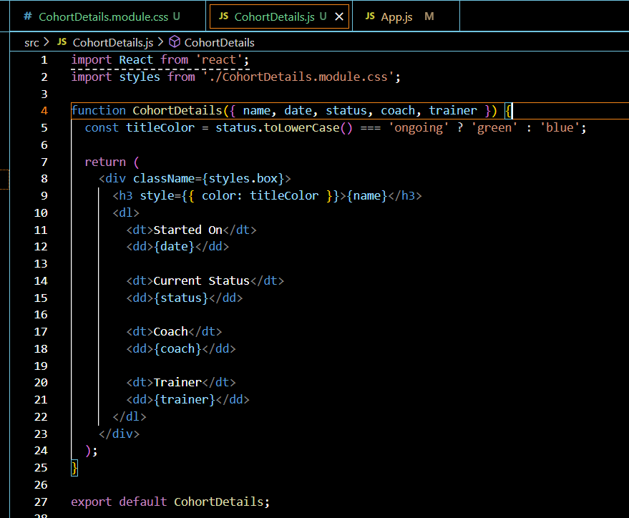**

**App.js:**

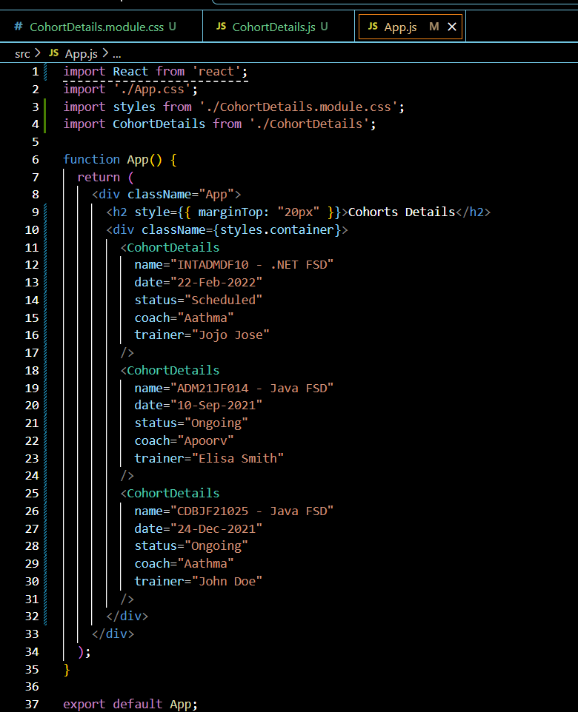

**Output:  
